**Searching and Sorting Algorithms**

**Question 1**

Use an insertion sort algorithm to put these European cities into alphabetical order

Note: An insertion sort is fairly straightforward but it is not sufficient to just take the list and rewrite it in order as that is not how a computer would do it. You should always show **every step** of the algorithm.

| **Riga** | **Paris** | **Oslo** | **Baku** | **Minsk** |
| --- | --- | --- | --- | --- |
|  |  |  |  |  |
|  |  |  |  |  |
|  |  |  |  |  |
|  |  |  |  |  |

**Question 2**

Six athletes compete in a long jump competition. Their best jumps are shown below

| 5.50 m | 5.32 m | 5.39 m | 6.50 m | 6.28 m | 6.14 m |
| --- | --- | --- | --- | --- | --- |

Show the stages of a bubble sort to list these jumps in order from shortest to longest. I have completed the first line for you.

Note: A common mistake is to forget the final pass because you realise that the list is already in order. You should always show a pass when **nothing changes** to complete the algorithm.

5.50 5.32 5.39 6.50 6.28 6.14 Compare 5.32 and 5.50 and swap them

5.32 5.50 5.39 6.50 6.28 6.14

**Question 3**

| 1992 | 2000 | 1989 | 1998 | 1990 |
| --- | --- | --- | --- | --- |

Show all the comparisons of a **bubble sort** algorithm to sort this list.

**Question 4**

Kim has a hand of playing cards, all of the same suit: 3,7,6,2,5

Arrange these cards in order from lowest to highest using an **simple sort**

**Question 5**

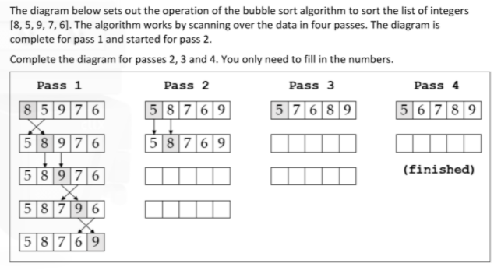

**Question 6**

(i)State the name of the sorting algorithm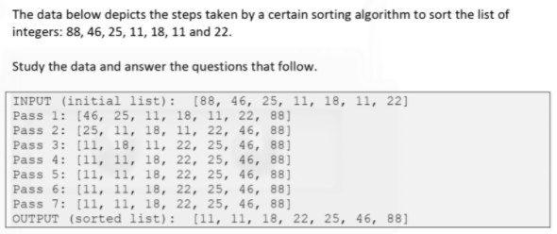

(ii) Explain how the algorithm works

(iii) Referring to pass 5, 6 and 7 identify a limitation of the algorithm

(iv) Suggest how this limitation could be overcome.

1. Six athletes compete in a long jump competition. Their best jumps are shown below

| 5.50 m | 5.32 m | 5.39 m | 6.50 m | 6.28 m | 6.14 m |
| --- | --- | --- | --- | --- | --- |

Show the stages of a bubble sort to list these jumps in order from shortest to longest. I have completed the first line for you.

Note: A common mistake is to forget the final pass because you realise that the list is already in order. You should always show a pass when **nothing changes** to complete the algorithm.

5.50 5.32 5.39 6.50 6.28 6.14 Compare 5.32 and 5.50 and swap them

5.32 5.50 5.39 6.50 6.28 6.14

1. Using the following list, sort the list using: 7, 3, 9,1 ,4
   1. Selection Sort
   2. Insertion Sort
   3. Bubble Sort
2. Using the following list, sort the list using: 3, 44, 38, 5, 47, 15
3. Insertion Sort
4. Bubble Sort
5. Selection Sort